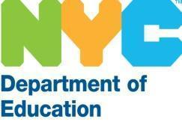 Melissa Aviles-Ramos, Chancellor
REQUEST FOR INFORMATION (RFI)
HIGH SCHOOL MATH CURRICULUM

This RFI is CLOSED.

Subject: Correction: Public RFI #1867 – High School Math Curriculum
Note:
On October 23rd, an email was sent in error. If you received that message, please disregard it.
The due date for Public RFI #1867 – High School Math Curriculum was October 14, 2025, by 4:00 PM EST. No further information is required at this time.
All questions regarding this RFI should be directed to curriculumreviews@schools.nyc.gov .
Please do not contact anyone listed in the incorrect October 23rd email.
Thank you for your attention and understanding.

