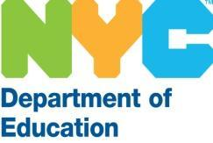 **David C. Banks, *Chancellor***

**NOTICE OF INTENT**

Negotiations with Sonova USA Inc

Sole Source contract - #B5851

The New York City Department of Education (“NYC DOE”) consists of approximately 1,800 Public Schools and 200 Central Offices throughout the City. In accordance with our Procurement Policy and Procedures, the DOE seeks to negotiate with Sonova USA Inc to formalize a five-year sole source contract to supply Phonak Hearing Assistive Technology for students with special hearing needs. For more information on these products, visit <https://www.sonova.com/en>.

**You are invited!**

If you can source these products, then please provide the following:

1. Company’s Legal Name.
2. Company’s Contact Person information.
3. A brief description of the products you can source including the website address where these products are publicly available.

If interested, please reply to this Notice of Intent on or before ***December 15th, 2023, by 4pm est.*** All information should be sent to Ryan Marron at [rmarron2@schools.nyc.gov](mailto:rmarron2@schools.nyc.gov).

Thank you for your continued support.