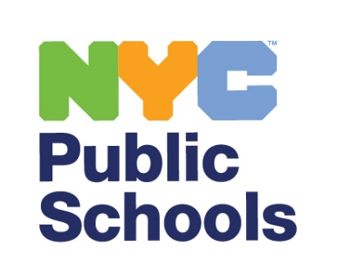

[INSERT DATE]
Dear Parent or Guardian:
New York City Public Schools (NYCPS) believes that our schools become stronger when we listen to our students. This year, students will be invited to participate in the Panorama Education Student Perception Survey, a confidential, research-based student survey used across the country to provide teachers with feedback from students about their classroom experiences.
About the Survey
Students in grades 6-12 will be invited to participate in the 2025-26 Student Perception Survey. The survey takes about 30 minutes or less to complete and will be administered between December 8, 2025 through January 16, 2026. Each school will determine the specific date(s) for administering the survey.
What the Survey Asks
Questions on the survey ask how your child is experiencing their classes, such as how supported your child feels by their teacher, and whether they find lessons engaging.
To learn more, please visit www.StudentPerceptionSurvey.nyc where you can read about the 2025-26 Student Perception Survey or contact your child’s school for more information.
Protecting Student Privacy
All student survey responses are anonymous and completely confidential, which means no one in the school will know how your child responded. Students are not asked to provide their names or ID numbers on the survey. The reports teachers receive do not show individual responses from any student, so you and your child can be confident that their survey answers will remain private.
Student Participation
Participation in the survey is voluntary. Families who do not want their child to participate can contact their child’s school. Students may also choose not to participate in the survey at the time of administration, even if you do not contact your child’s school. Additionally, a student may skip any question they do not feel comfortable with or do not wish to answer.
If you would like more information or would like to review a copy of the survey questions, please visit www.StudentPerceptionSurvey.nyc or contact your child’s school.

Sincerely,
New York City Public Schools

2025-26 Student Perception Survey

Family FAQs

(Frequently Asked Questions)

Why are students being asked to take a student survey?
New York City Public Schools (NYCPS) believes students should have the opportunity to share their insights about the teaching practice they experience in their classrooms. Student voice provides valuable information to educators on ways to improve their practice to better meet students’ needs. Additionally, teachers can use the information to focus on specific areas of their practice; that is, the areas where they are doing well and the areas where there is room for improvement. Please note, the Student Perception Survey is for formative purposes only and not being administered as a part of Advance, New York City’s system for teacher development and evaluation.

Who will take the survey?
Students in grades 6-12 will be asked to take the survey. Students should be taught by the teacher for at least four weeks prior to survey administration to participate in the survey.

What types of questions are on the survey?
The survey will consist of 36 questions and measures students’ perceptions and attitudes about a specific teacher and their classroom. Specifically, students answer questions across six domains: Pedagogical Effectiveness, Classroom Climate, Classroom Rigorous Expectations, Classroom Engagement, Shared and Inclusive Curriculum, and Teacher-Student Relationships. Items on the survey cover topics such as how supported students feel by their teachers and whether they find lessons engaging. There will be 7 optional demographic questions as well. The survey questions can be found on the 2025-26 Student Perception Survey website at www.StudentPerceptionSurvey.nyc.

Will anyone see students’ answers?
All student survey responses are kept completely confidential. No one will ever track answers back to an individual student, and students are not asked to share their names or ID numbers. Individual student responses will never be shared with teachers.

Is my child required to take the survey?
No, parents or guardians may opt their child out of the survey by following the guidelines provided by your child’s school. Students may also opt out of participating in the survey at the time it is administered. Additionally, students may skip any questions on the survey they do not wish to answer.

When will the Student Perception Survey be administered?
The administration window is from December 8, 2025 through January 16, 2026. Schools will determine when is best to administer the survey within that time frame.

