**Highlights from the NYC School Survey**

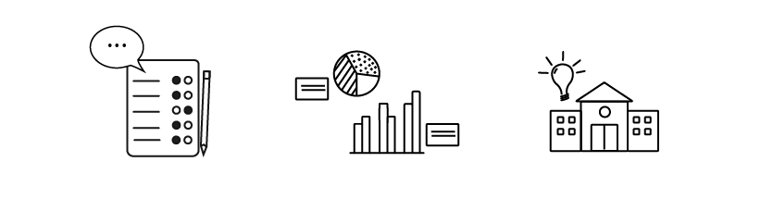

**What is the NYC School Survey?**

The NYC School Survey is one of the nation’s largest education surveys. Each year, families, teachers, and students in grades 6-12 take the NYC School Survey to share feedback about their schools. Feedback gathered through the survey can help improve your child’s learning environment by helping schools identify areas for growth and strength.

**Who in our school did we hear from this year?**

* XX of students
* XX of parents/guardians
* XX of teachers

**What are we proud of? Where can we improve?**

[Review your 2024 NYC School Survey results and insert examples of which results stood out to you as a school leader. For example: 85% of parents/guardians agreed or strongly agreed that teachers work closely with them to meet their child's needs. Also, insert examples of which results you have identified to help guide decision making at your school. For example: 62% parents/guardians agreed that they feel well-informed by the communications they receive from their school.]

**How does your feedback help our school?**

To better align with our school mission/goals, based on the feedback we received, we... [consider inserting the areas you identified as indicating program strengths. What is your school or program doing that is leading to positive feedback in these areas? What are issues or areas the group would like to prioritize as needing additional focus and/or attention?]

The results for the NYC School Survey are also used to help measure school quality in our School Quality Snapshot released yearly. The School Quality Snapshot contains background information about each school and strives to present its strengths through multiple measures, including data from the NYC School Survey and performance metrics.

[**https://tools.nycenet.edu/snapshot**](https://tools.nycenet.edu/snapshot)

**Explore your results:**

Visit the link below to view your school’s NYC School Survey results. You can also visit [nycschoolsurvey.org](http://nycschoolsurvey.org) and click on “survey results page” in the Frequently Asked Questions section.

**<https://secure.panoramaed.com/nycdoe/understand?auth_token=NeMqBRG7xyKtyeqmK_Nd>**